**Inferential Analysis**

**Problem Statement or Requirement:**

1)Replace the NaN values with correct value. And justify why you have chosen the same.

2)How many of them are not placed?

3)Find the reason for non-placement from the dataset?

4)What kind of relation between salary and mba_p?

5)Which specialization is getting minimum salary?

6)How many of them getting above 500000 salaries?

7)Test the Analysis of Variance between etest_p and mba_p at signifance level 5%. (Make decision using Hypothesis Testing)

8)Test the similarity between the degree_t (Sci&Tech) and specialisation (Mkt&HR) with respect to salary  at significance level of 5%.(Make decision using Hypothesis Testing)

9)Convert the normal distribution to standard normal distribution for salary column

10)What is the probability Density Function of the salary range from 700000 to 900000?

11)Test the similarity between the degree_t(Sci&Tech)with respect to etest_p and mba_p at significance level of 5%.(Make decision using Hypothesis Testing)

12)Which parameter is highly correlated with salary?

13) Plot any useful graph and explain it.

1)Replace the NaN values with correct value. And justify why you have chosen the same.

After seeing the dataset we have check whether its has the NAN values or outliers.

Ways to find out NAN values are as follows:

* Check why nan values occurs
* Rectify NAN values by using any of this according to problem statement

1. Use central tendency for missing values.
2. Delete entire row.
3. Respective to the problem statement replace the missing value.
4. Consider as a semi supervised model,so that we can predict the missing value.

2)How many of them are not placed?

67 students were not placed .

3)Find the reason for non-placement from the dataset?

Because they don’t perform well in the interview process.

4)What kind of relation between salary and mba_p?

The relation between salary nd mba _p is 0.139823 i.e positive correlation salary is directly propositional to the mba _p.

5)Which specialization is getting minimum salary?

Mrk & HR .

6)How many of them getting above 500000 salaries?

Three persons got salary above 500000.

7)Test the Analysis of Variance between etest_p and mba_p at signifance level 5%. (Make decision using Hypothesis Testing)

Ttest_indResult(statistic=5.239138271183206, pvalue=3.868851438197328e-07)

9)Convert the normal distribution to standard normal distribution for salary column

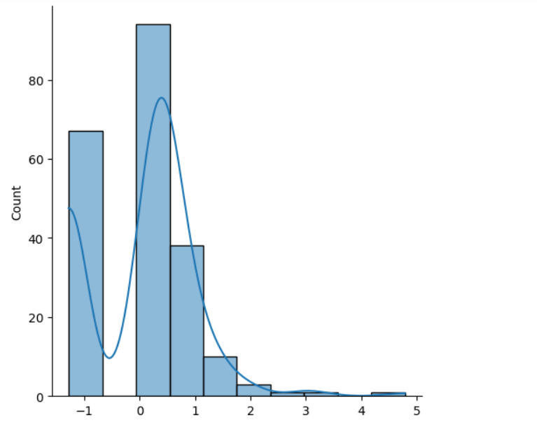

10)What is the probability Density Function of the salary range from 700000 to 900000?

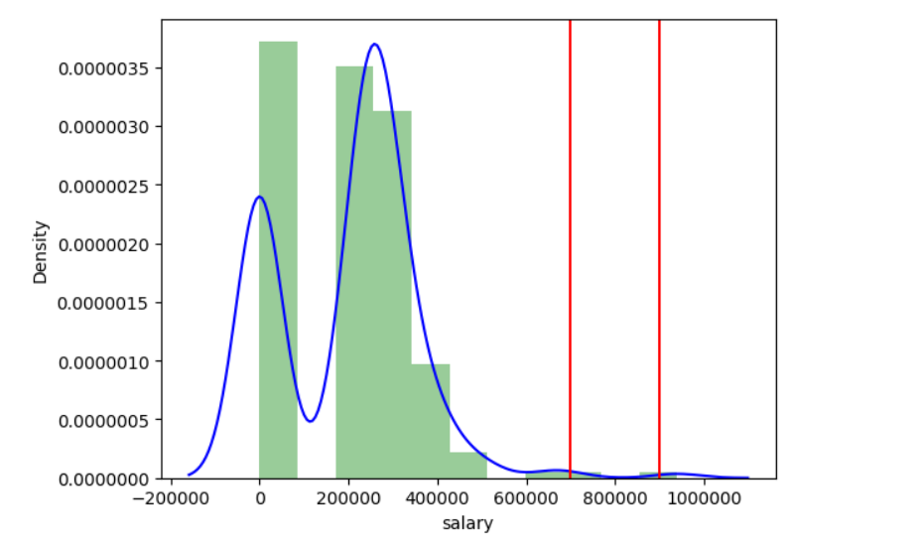

12)Which parameter is highly correlated with salary?

**specialisation**

13) Plot any useful graph and explain it.